## 1. Buddy Allocator Test (buddy_test.txt)
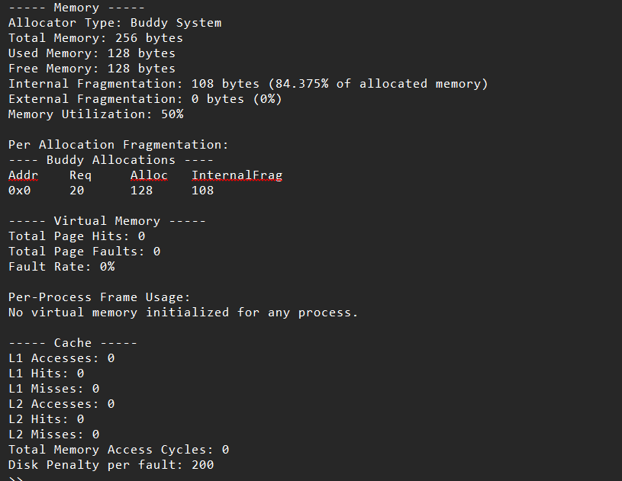
External fragmentation is 0 showing correctness of buddy .Internal fragmentation is high showing that conversion in power of 2 of requested size .Cache and virtual memory stuffs is 0 because they r not used yet .

## 2.Linear Allocator Test(linear_allocation_test.txt)
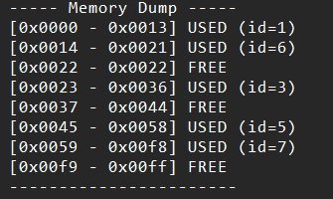 this is ff (first fit)
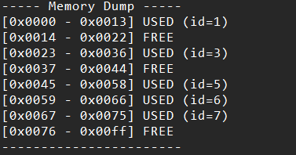 this is wf (worst fit)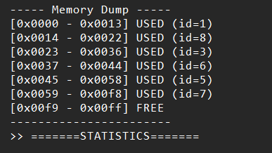 this is bf(best fit)
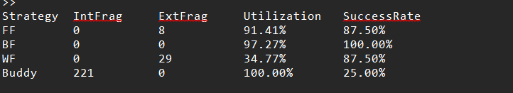
Clearly we can see how first fit searches for the firstwmpty block >= required size and best fit searches for the closest >= size and worst fit searches largest >= size . Thus best fit have highest success rate .

##3. Cache test ( Cache_access_test.txt)
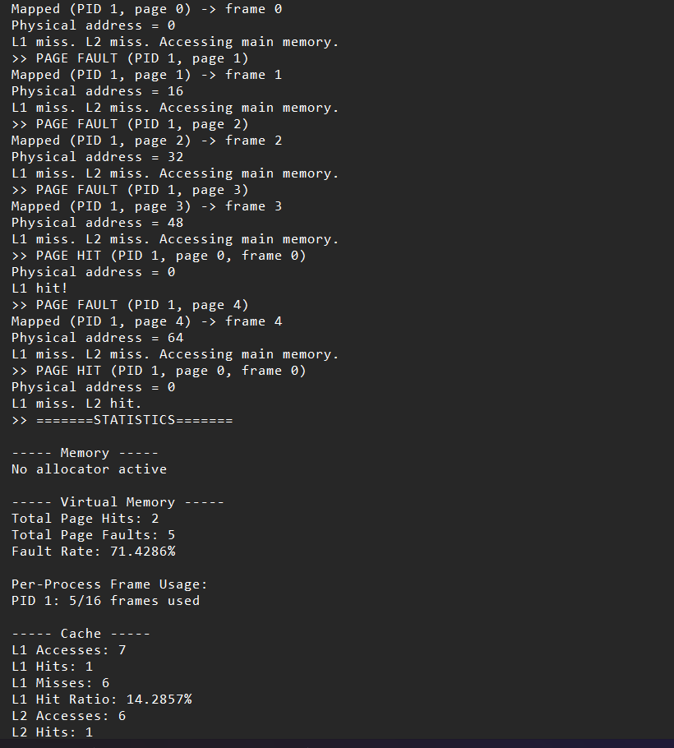
We accessed physical address 0 10 32 48 all showing cache misses as expected . after this we did access 0 to show that cache is implemented by fifo not lru because if this would have been lru then on accessing 64 10 should be evicted but on accessing 0 again we found it was evicted showing fifo behaviour.also l2 shows a hit showing higher cache size than l1.

##4. Virtual Memory test (vm_access_test.txt)
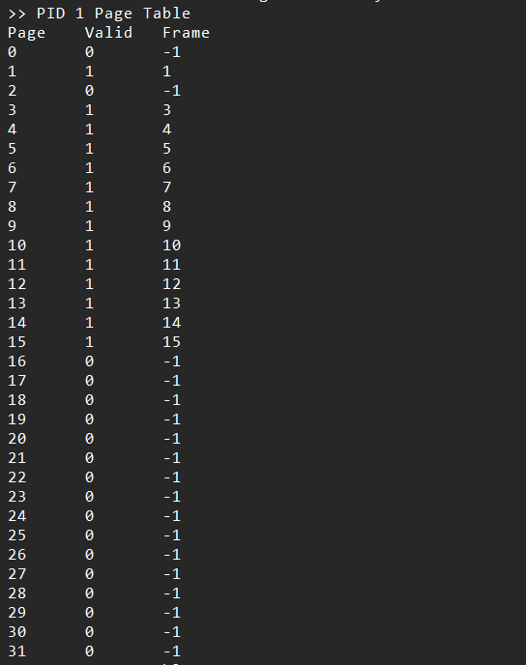
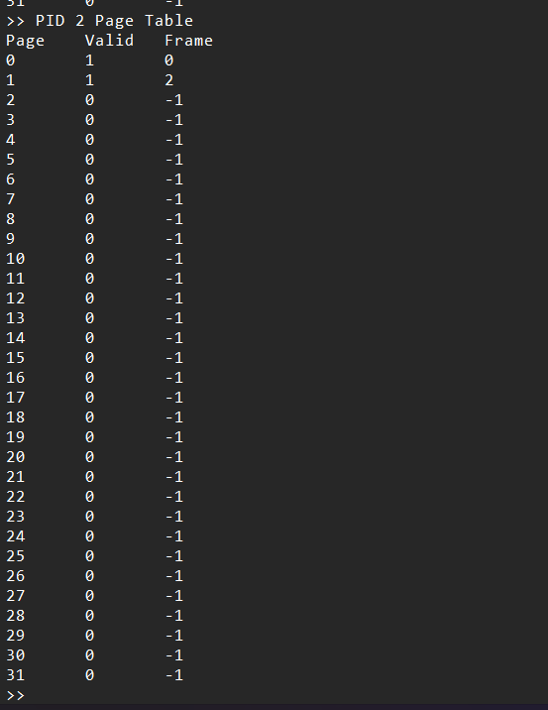
These pids table shows that lru policy is being followed

